Infosys Springboard Virtual Internship 6.0 Completion Report

Team Details
Batch Number : 10 Start date :25-NOV-25
Team Number:4
Names:
S.no | Name
1 | Polepalli Keerthi
2 | Prashant Kumar Pathak
3 | Nagamani Mannempalli
4 | Vaishnavi vankalas
5 | Jerusha

Internship Duration: 8 Weeks

- Project Title

INVENTRA INTELLIGENT INVENTORY MANAGEMENT SYSTEM

- Project Objective
- Securely authenticate users with robust authentication and authorization mechanisms (including registration,
login, JWT-based security, and password recovery workflows).
- Manage inventory efficiently by allowing users to add, view, update, and delete products and maintain their
stock data in a backend database.
- Monitor and track inventory levels, including identifying and highlighting low-stock items, to support timely
restocking and prevent stockouts.
- Provide intuitive dashboards and reporting views that enable users to visualize inventory data and trends
through frontend pages.
- Separate frontend presentation and backend logic using RESTful APIs built with Spring Boot and MySQL,
ensuring modularity and extensibility for future growth or real-world usage.

- Project description in detail

The Inventra – Intelligent Inventory Management System is designed to modernize and streamline traditional inventory workflows that often suffer from manual errors, lack of real-time visibility, and inefficient stock tracking. By integrating secure authentication, structured product management, and automated inventory monitoring, the system provides organizations with a centralized platform to record, track, and manage their stock with accuracy and traceability. Unlike manual spreadsheets or isolated billing systems, Inventra maintains a persistent digital record of products, categories, suppliers, and quantity levels, enabling users to understand their operational inventory health at any point in time. Through defined modules—Authentication, Product Management, Inventory Alerts, and Reports—the system ensures that information access is role-based, data updates are validated, and stock levels are continuously observed for critical fluctuations
Inventra_All_Classes
.
Beyond product CRUD operations, Inventra’s intelligent alerting and analytics capabilities serve as a strategic support tool for business decision-making and procurement planning. Low-stock detection prevents dangerous stockouts and operational delays, while reporting and analytical dashboards offer insights into stock movement, consumption patterns, and restocking requirements. The platform leverages a scalable backend supported by Spring Boot and MySQL, with a modular frontend designed for usability and clarity, making the system suitable for retail shops, warehouses, wholesalers, and institutional inventory environments. Through this combination of automation, structured data handling, and visual reporting, Inventra not only enhances day-to-day inventory operations but also transforms inventory management into a data-driven, proactive, and intelligent process aligned with modern business needs.

- Timeline Overview

Week | Activities Planned | Activities Completed
Week 1 | Project kickoff, requirement understanding, workflow analysis, tech stack & architecture planning | Conducted project initiation meeting, finalized module scope (Auth, Product, Inventory Alerts, Reports), confirmed Spring Boot + MySQL + JWT + HTML/CSS/JS stack
Week 2 | Authentication & role-based access module | Implemented login, registration, JWT security, and role separation for Admin & Employee
Week 3 | Product Management Module (Part-1) | Implemented Product CRUD backend logic, designed database tables, connected backend with MySQL, tested CRUD using Postman
Week 4 | Product Management Module (Part-2) & Stock Management | Integrated CRUD with UI, added stock quantity fields, validated product forms, ensured product updates reflect in the database
Week 5 | Inventory Alerts & Notifications | Implemented low-stock alert logic, validated threshold conditions, and tested alert triggers
Week 6 | Transaction Logging & Stock Movement Tracking | Added stock IN/OUT transaction entries, implemented automatic stock updates, and synced movements with database
Week 7 | Reporting & Dashboard UI | Developed dashboard showing stock count, product lists, low-stock items, and enabled basic downloadable report functionality
Week 8 | Documentation, Testing, and Final Presentation | Completed documentation, tested functional modules end-to-end, polished UI, prepared demo, and submitted final report

5a. Key Milestones

Milestone | Description | Date Achieved
Project Kickoff | Initial briefing, requirement clarification, module identification (Authentication, Product, Inventory Alerts, Reports) and tech-stack finalization (Spring Boot, MySQL, JWT, HTML/CSS/JS). | 29-NOV-25

Milestone | Description | Date Achieved
Prototype / First Draft | Completion of Authentication module with role-based access, JWT login, and basic Product CRUD backend services connected to MySQL. | 13-DEC-25
Mid-Term Review | Demonstrated functional CRUD operations, stock management, alert mechanism logic, and basic UI integration; received feedback for improvements and reporting features. | 27-DEC-25
Final Submission | Completed dashboard, inventory transactions, low stock alerts, downloadable reports, full documentation, testing, and integration of frontend & backend. | 10-JAN-25
Presentation | Delivered final demonstration showcasing authentication, product management, inventory alerts, transaction records, and reporting dashboard with end-to-end workflow. | 24-JAN-25

5b. Project execution details

- The Inventra – Intelligent Inventory Management System was developed in planned stages using a full-stack web development approach. The project started by understanding the problem, collecting requirements, and dividing the work into four main parts: Authentication, Product Management, Inventory Alerts, and Reports. After this, the technology stack was finalized using Spring Boot for backend APIs, MySQL for data storage, Html, Css, Js for the user interface, and JWT tokens for secure access. The database was designed with tables for users, products, and inventory records. The backend work began with setting up user authentication and role-based access, ensuring that only registered users could manage or view inventory data.
- After completing authentication, the product and inventory modules were implemented and connected to the database. This allowed users to add, update, delete, and list products, while inventory levels were stored and tracked automatically. A low-stock alert mechanism was added to notify users when quantities fell below a specified limit. Once the backend was tested using Postman, the frontend dashboard was built to display products, inventory status, and alerts using REST API calls. The final stages included adding simple reporting features, testing all modules for correctness and usability, and preparing the project for demonstration. The completed system successfully showed the full flow from login → managing products → tracking inventory → seeing alerts → viewing reports, providing a practical and working inventory management solution.

6. Snapshots / Screenshots

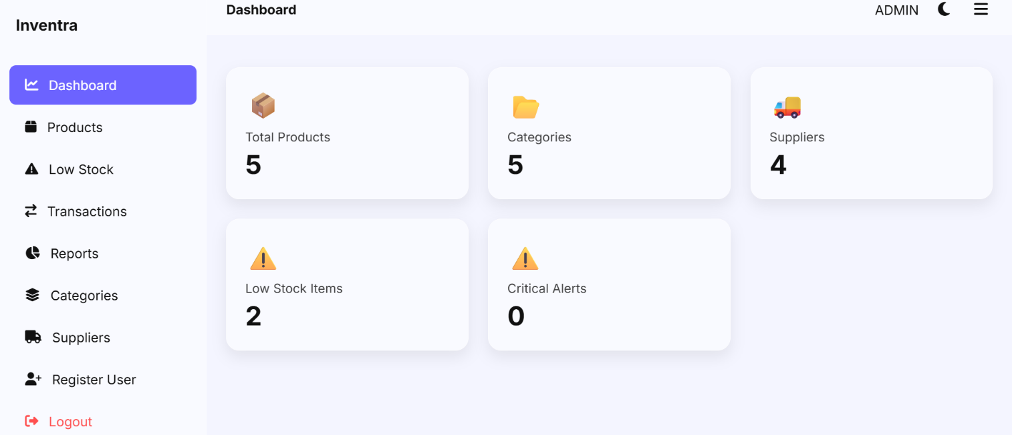

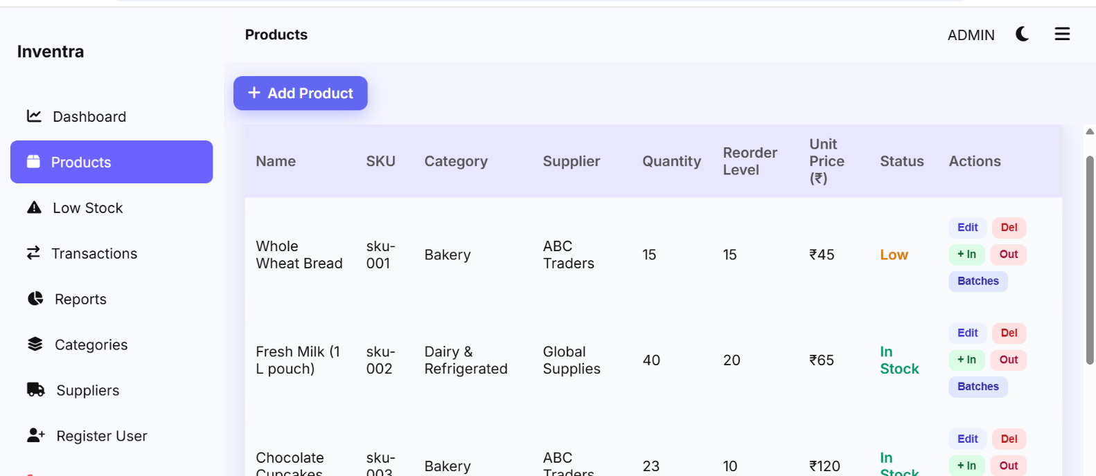

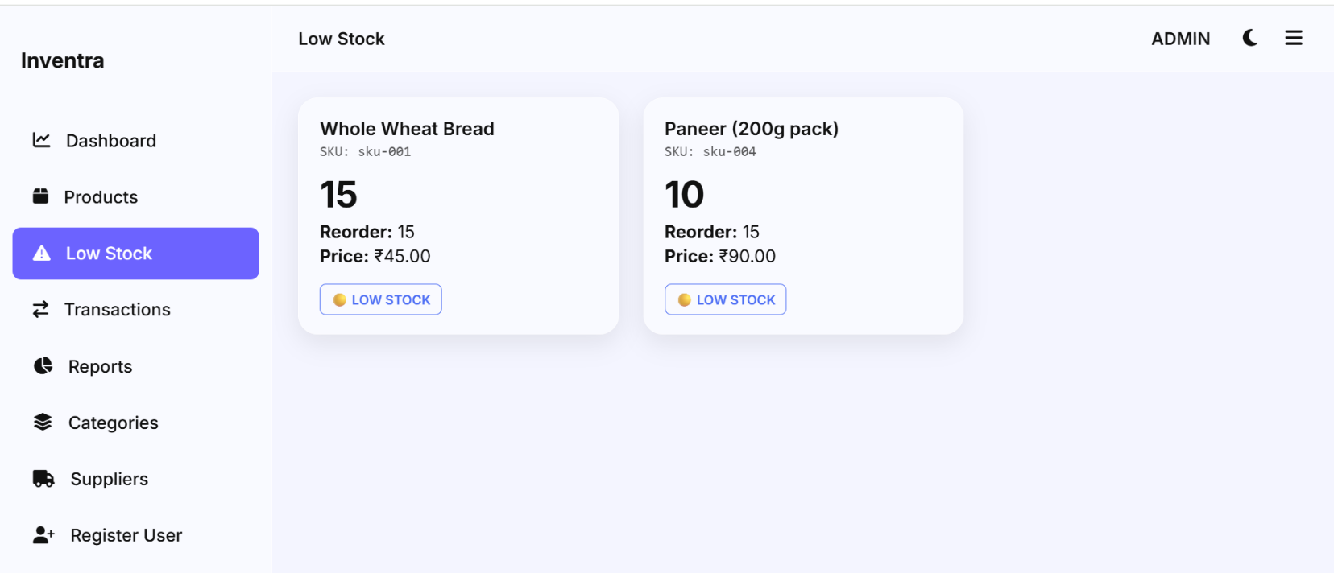

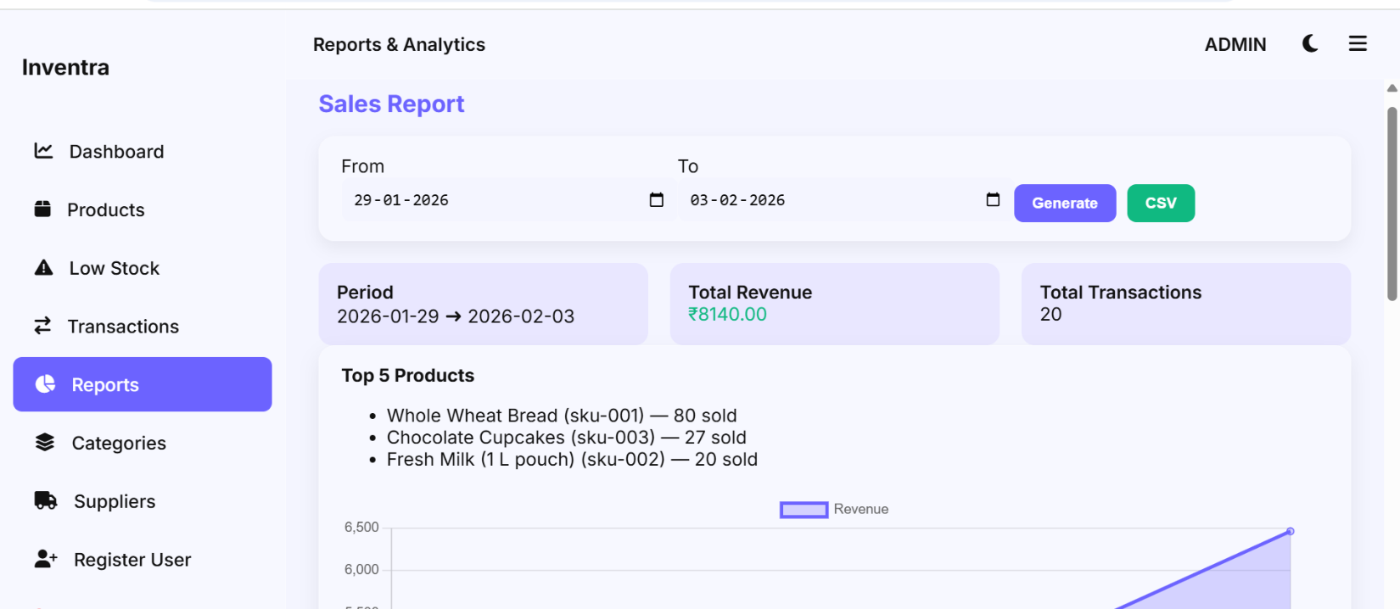

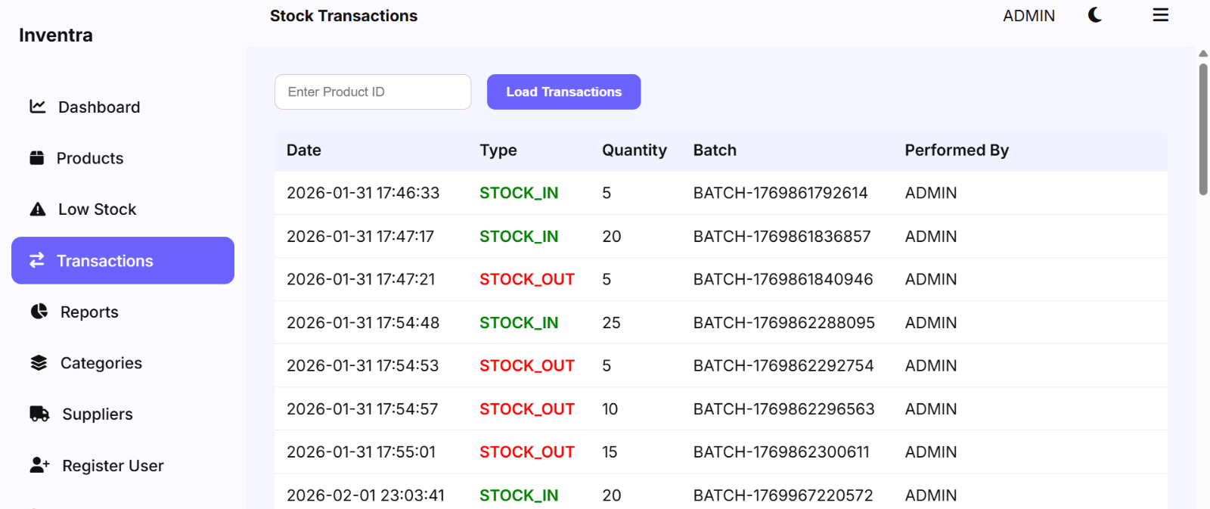

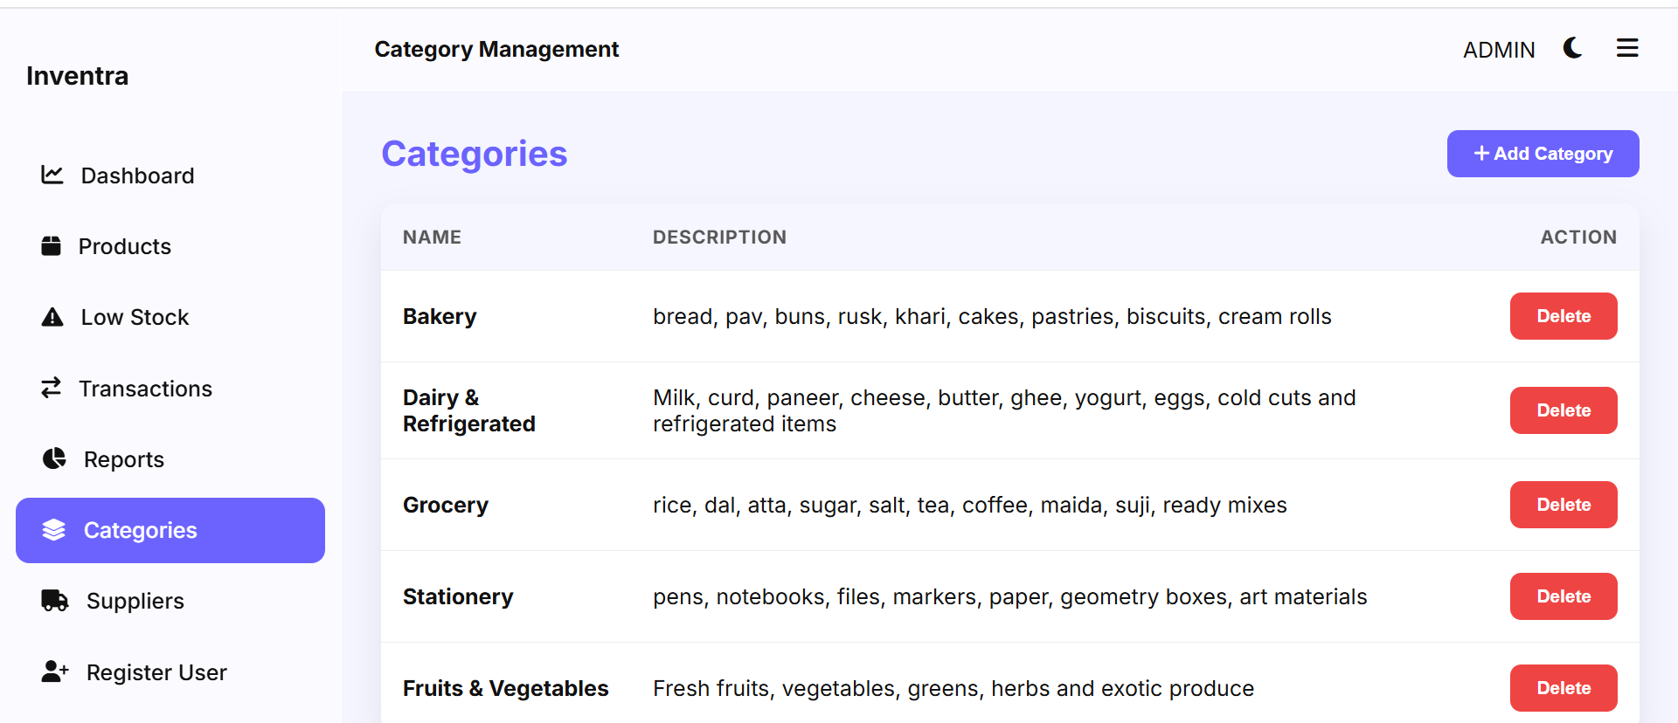

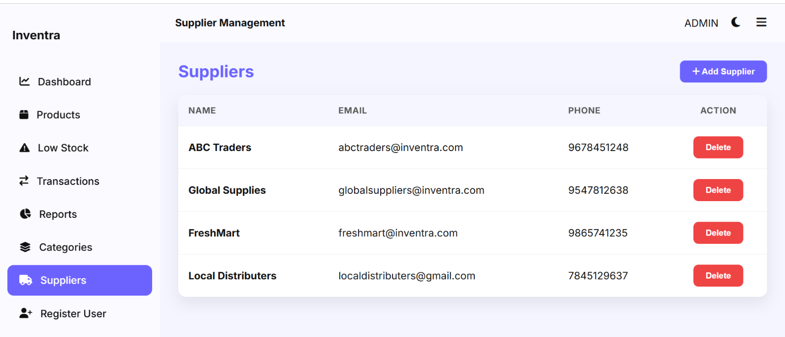
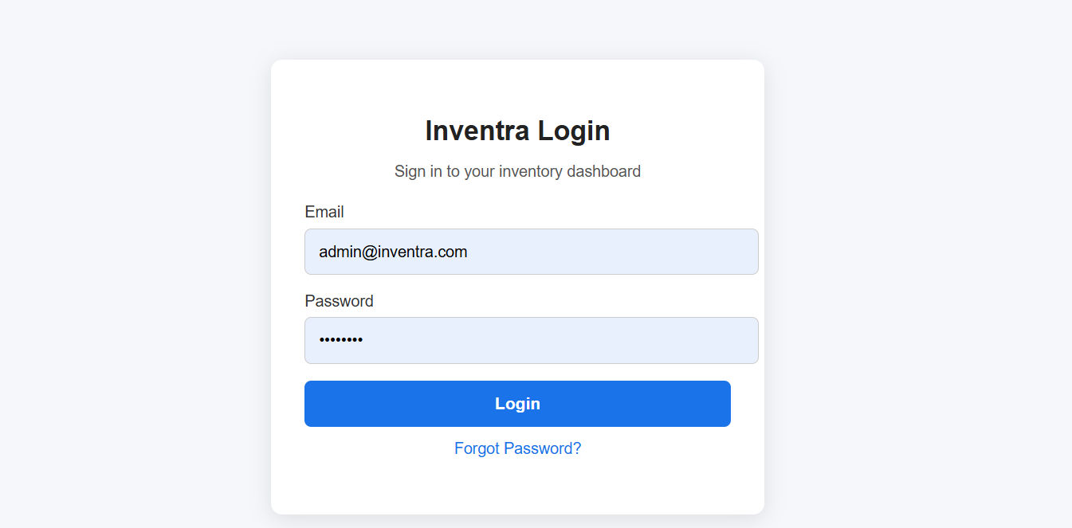

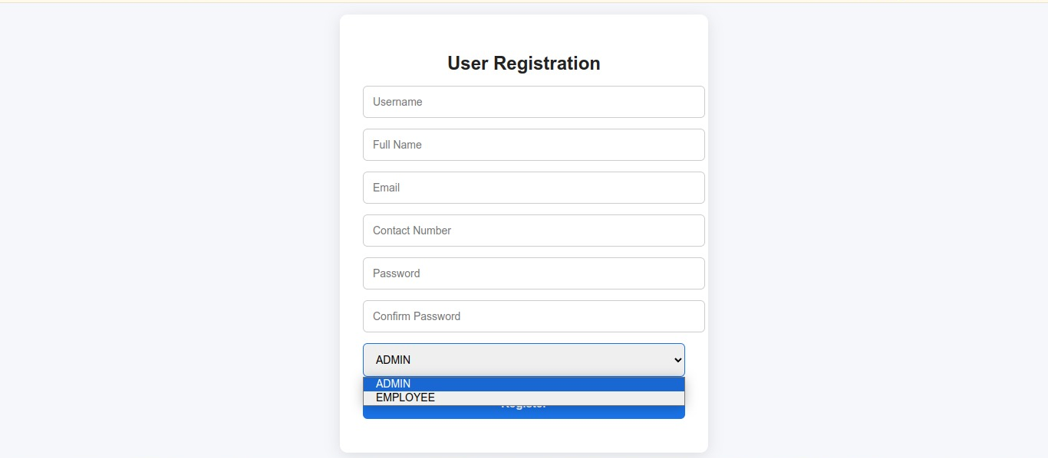

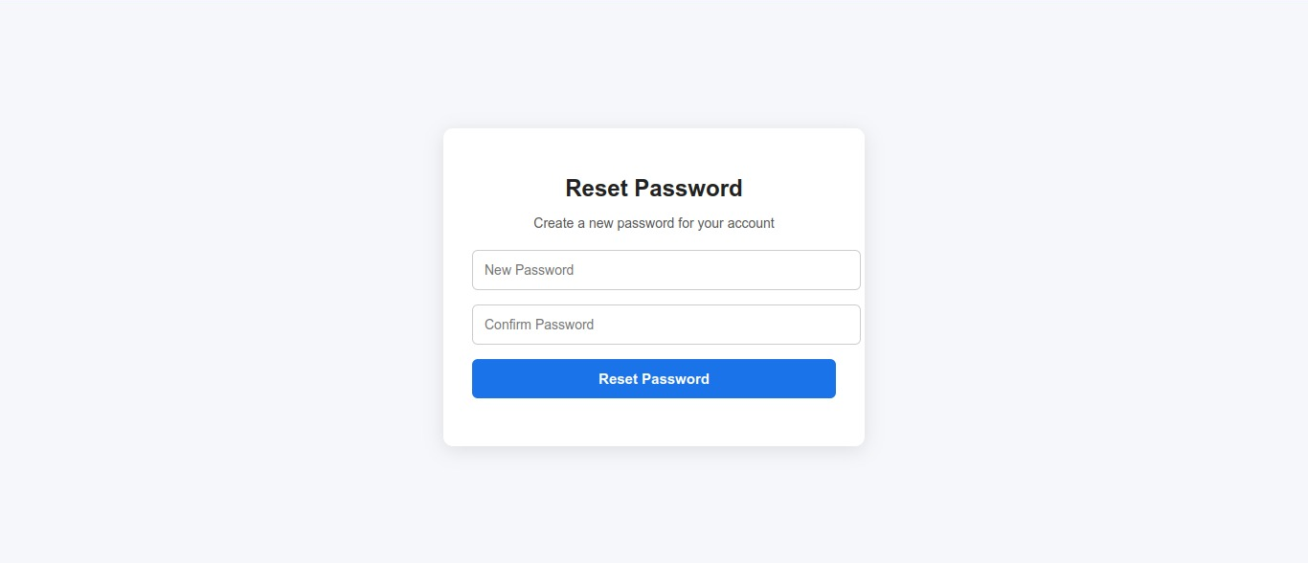

7. Learnings & Skills Acquired

Full-Stack Development Workflow – Understood how to plan, build, integrate, and test backend and frontend modules in stages.

Backend Development with Spring Boot – Learned to create REST APIs, service layers, and repositories using Spring Boot and Java.

JWT Authentication & Security – Gained experience in implementing login, token-based authentication, and secure access control.

Database Design & MySQL Integration – Designed tables, managed relationships, wrote queries, and integrated backend with MySQL using JPA/Hibernate.

REST API Usage & Testing – Practiced working with REST endpoints, sending requests, and validating API responses using tools like Postman.

Frontend Development with HTML, CSS, JS – Built interactive UI screens for login, product listings, alerts, and reports using components and API calls.

Inventory & Product Management Logic – Learned to handle CRUD operations, track stock levels, update quantities, and manage product attributes.

Alert & Notification Mechanisms – Implemented logic to detect low-stock items and trigger alerts for timely restocking.

Reporting & Dashboard Visualization – Created dashboard pages to display inventory summaries, product counts, and analytics for decision-making.

Testing & Debugging Skills – Improved debugging abilities for both frontend and backend, and tested different user workflows for correctness.

Project Documentation & Presentation – Enhanced skills in writing documentation, explaining modules, and presenting end-to-end project flow.

Team Collaboration & Communication – Improved coordination, presentation skills, and project documentation habits through weekly milestone reviews.

7. Challenges Face

Challenge 1: Securing User Access
Problem: Implementing authentication so that only valid users can access and manage inventory was difficult at the start.
Solution: Used JWT token-based authentication and role-based access control to secure APIs and prevent unauthorized usage.

Challenge 2: Managing Product & Inventory Data
Problem: Handling multiple data fields (product name, category, supplier, quantity, etc.) and maintaining consistency during updates was tricky.
Solution: Designed a proper relational database schema in MySQL and used Spring Data JPA for clean CRUD operations and data integrity.

Challenge 3: Stock Level Monitoring & Alerts
Problem: Detecting low-stock items dynamically and keeping the UI updated with alert notifications required additional logic.
Solution: Added threshold fields for products, created backend alert conditions, and displayed alerts on the frontend for quick action.

Challenge 4: Frontend–Backend Communication
Problem: Sending requests from HTML/JS to the backend and handling JSON responses caused CORS errors and format issues.
Solution: Enabled CORS in Spring Boot, used fetch() for AJAX calls in JavaScript, and validated response formats for smooth communication.

Challenge 5: Error Handling & Debugging
Problem: JWT errors, database exceptions, and CORS issues made debugging time-consuming.
Solution: Implemented exception handlers in Spring Boot, used browser console logs for frontend debugging, and validated tokens properly.

8.Testimonials from team
As part of the internship journey, our team experienced a realistic software development workflow. We explored new technologies, learned how to connect frontend and backend modules, and improved our understanding of secure inventory control. Despite academic schedules and challenges during coding, the team communicated well, divided tasks properly, and helped each other during debugging. Regular discussions, documentation sharing, and testing sessions made the progress smooth and productive.

9.Conclusion
The Inventra – Intelligent Inventory Management System provided a complete learning experience across the major stages of full-stack development including requirement analysis, database design, backend implementation, frontend integration, authentication setup, testing, and documentation. By building this system, we gained hands-on experience in Spring Boot APIs, MySQL integration, JWT-based security, and UI development with HTML, CSS, and JavaScript. The final system demonstrates secure login, product management, inventory tracking, low-stock alerts, and reporting features, making it a practical solution for managing small or medium-scale business inventories. Overall, this project significantly improved both technical confidence and industry readiness in web application development.
10.Acknowledgements

We would like to express our sincere gratitude to our mentor for the continuous support, encouragement, and valuable feedback throughout this project. Your guidance helped us understand backend development, database handling, and security techniques in a more practical way. We also thank Infosys Springboard for providing a structured virtual internship environment, learning resources, and motivation to successfully complete this project. This experience has played an important role in expanding our technical skills and preparing us for real-world software development challenges.


Virtual Internship 6.0

pg. 12

